Project Report On

Bloom - The Vibrant Blogging Platform

## COMPUTER SCIENCE AND ENGINEERING

**B.E. Batch-2022 In**

## 2024-2025



#### Under the Guidance of: Submitted By:

Mr. Sudeep Sharma Samiksha , 2210992587 Sanskar, 2210992251

Sanisth, 2210992247

Samar, 2210992234

Salil, 2210992230

**Department of Computer Science and Engineering** Chitkara University Institute of Engineering & Technology, Chitkara University, Punjab

# CERTIFICATE

This is to be certified that the project titled “Bloom-The Vibrant Blogging Platform ” has been submitted for the Bachelor of Computer Science Engineering at Chitkara University, Punjab during the academic semester July 2024-December 2024 is a Bonafede piece of project work carried out by Samiksha(2210991524), Sanskar(2210991540), Sanisth(2210992247), Samar(2210992234), Salil(2210992230) towards the partial fulfillment for the award of the course Integrated Project (CS 203) under the guidance of Sudeep Sharma and supervision.

**Sign. of Project Guide** : Mr Sudeep Sharms

**CANDIDATE’S DECLARATION**

We, Samiksha(2210991524), Sanskar(2210991540),Sanisth(2210992247), Samar(2210992234), Salil(2210992230) G-22, B.E.-2022 of the Chitkara University, Punjab hereby declare that the Integrated Project Report entitled “Bloom-The Vibrant Blogging Platform” is an original work and data provided in the study is authentic to the best of our knowledge. This report has not been submitted to any other Institute for the award of any other course.

|  |  |  |  |
| --- | --- | --- | --- |
| Samiksha | Sanskar | Sanisth | Samar |
| 2210992587 | 2210992251 | 2210992247 | 2210992234 |
| Salil |  |  |  |
| 2210992230 |  |  |  |
| Place: Chitkara University Date: September 2, 2024 |  |  |  |

**ACKNOWLEDGEMENT**

It is our pleasure to be indebted to various people, who directly or indirectly contributed in the development of this work and who influenced my thinking, behavior and acts during the course of study. We express our sincere gratitude to all for providing me an opportunity to undergo Integrated Project as the part of the curriculum. We are thankful to Mr Sudeep Sharma for his support, cooperation, and motivation provided to us during the training for constant inspiration, presence and blessings. Lastly, we would like to thank the almighty and our parents for their moral support and friends with whom we shared our day-to day experience and received lots of suggestions that improve our quality of work.

|  |  |  |  |
| --- | --- | --- | --- |
| Samiksha | Sanskar | Sanisth | Samar |
| 2210992587  Salil | 2210992251 | 2210992241 | 2210992234 |
| 2210992230 |  |  |  |

# Abstract

Bloom is an innovative, robust, and scalable backend solution for a dynamic blogging platform designed to enhance user engagement and content management. The project focuses on providing a seamless experience for bloggers and readers by incorporating advanced features such as customizable content, user-generated posts, social interactions, and personalized recommendations. Bloom’s backend is built using modern web development technologies, ensuring high performance, security, and scalability.

The architecture of the platform is based on a microservices design, allowing efficient management of user accounts, blog posts, comments, and notifications. A RESTful API facilitates smooth communication between the frontend and backend, providing real- time content updates and interactions. To ensure a smooth user experience, the backend implements strong user authentication, data validation, and access control mechanisms.

## Introduction

#### Background

The rise of digital platforms has significantly altered the way we communicate, with video content gaining immense popularity. Vlogging, in particular, has become a mainstream form of digital expression. Today, platforms like YouTube, TikTok, and Instagram provide avenues for individuals to showcase their talent, opinions, and experiences through videos. The demand for easy-to-use and customizable vlogging platforms has also grown, especially for creators who want to build a more personal relationship with their followers.

Despite the growth of vlogging, many content creators still struggle with technical aspects like video hosting, viewer interaction, and content organization. This project aims to address these gaps by creating a dedicated vlogging website that allows for seamless video uploading, real-time comments, user interaction, and analytics to help creators better understand their audience.

* 1. **Problem Statement**

The problem arises from the need for a user-friendly, feature-rich platform that addresses the growing demand for vlogging. Existing platforms, while popular, come with their own set of challenges, such as limitations in customization, high competition, and restricted interaction between vloggers and viewers.

#### Key issues include:

**Difficulty in organizing content**: Creators need a platform that allows easy categorization and management of their videos.

**Limited engagement features**: Many platforms offer basic commenting but lack tools for building a dedicated community.

**Monetization challenges**: Creators often find it hard to monetize their content effectively.

**Scalability:** Existing platforms may not provide adequate scalability for creators with large audiences.

This project seeks to solve these problems by providing an easy-to-use platform with advanced features for video uploading, organization, interaction, and monetization.

## Software and Hardware Requirement Specification

### Methods

* **Code Editor/IDE**:
  + **Tools**: Visual Studio Code, Sublime Text, IntelliJ IDEA.
  + **Availability**: Free download from their official websites (e.g., Visual Studio Code).

### Programming/Working Environment

* **Programming Languages and Frameworks**:
  + **JavaScript (for Frontend and Backend)**:
    - **Tools**: Node.js runtime, npm (Node Package Manager).
    - **Availability**: Free download from the Node.js official website.
  + **Frontend Libraries and Frameworks**:
    - **React.js**: Available via npm (install using npm install react).
    - **Tailwind CSS**: Available via npm (install using npm install tailwindcss).
    - **Availability**: Documentation and installation guides can be found on the official React and Tailwind CSS websites.
* **Backend Frameworks**:
  + **Express.js**: Available via npm (install using npm install express).
  + **Availability**: Documentation is accessible on the Express.js official website.

### 3.3 Requirements to Run the Application

* **Database Management System (DBMS)**:
  + **MongoDB (NoSQL Database)**:
    - **Tools**: MongoDB, MongoDB Atlas (for cloud database), Mongoose (ODM).
    - **Availability**: MongoDB can be downloaded for free from the official MongoDB website. MongoDB Atlas offers a free tier for cloud-based databases.

## Database Analyzing, design and implementation

Data analysis: Identify the key entities and relationships in the Doctor Direct.

Database design: Create an Entity-Relationship (ER) diagram to visualize the database structure.

Database implementation: Implement the database schema using MongoDB.

an Entity-Relationship (ER) diagram to reflect the database structure of your doctor appointment system.

## Program’s Structure

* Wireframing: Create visual representations of the user interface.
* Prototyping: Develop interactive prototypes to test the user experience.
* GUI development: Implement the user interface using Tailwind and JavaScript (with a framework like React).

The structure of the Bloom is critical to ensuring that the application is modular, maintainable, and scalable. The system is developed using the MERN stack, which includes MongoDB, Express.js, React.js, and Node.js. Each component of this stack plays a distinct role in the architecture, working together to deliver a seamless user experience and efficient backend processing.

## 5.1 Application Architecture

Presentation Layer (Frontend)

* React.js:

This is the frontend framework responsible for building the user interface (UI). React.js is used to create reusable UI components, manage user interactions, and handle the state of the application.

## Application Logic Layer (Backend)

* **Node.js:**

Node.js serves as the runtime environment for the server-side application. It handles the execution of JavaScript code on the server, managing client requests and responses**.**

#### Express.js:

Express.js is the web application framework used with Node.js to create RESTful APIs. It simplifies the process of routing, middleware integration, and handling HTTP requests.

#### Data Layer (Database)

* **MongoDB**

MongoDB is a NoSQL database used to store and manage application data. Its document-oriented structure is particularly well-suited for the

## Project snapshots:

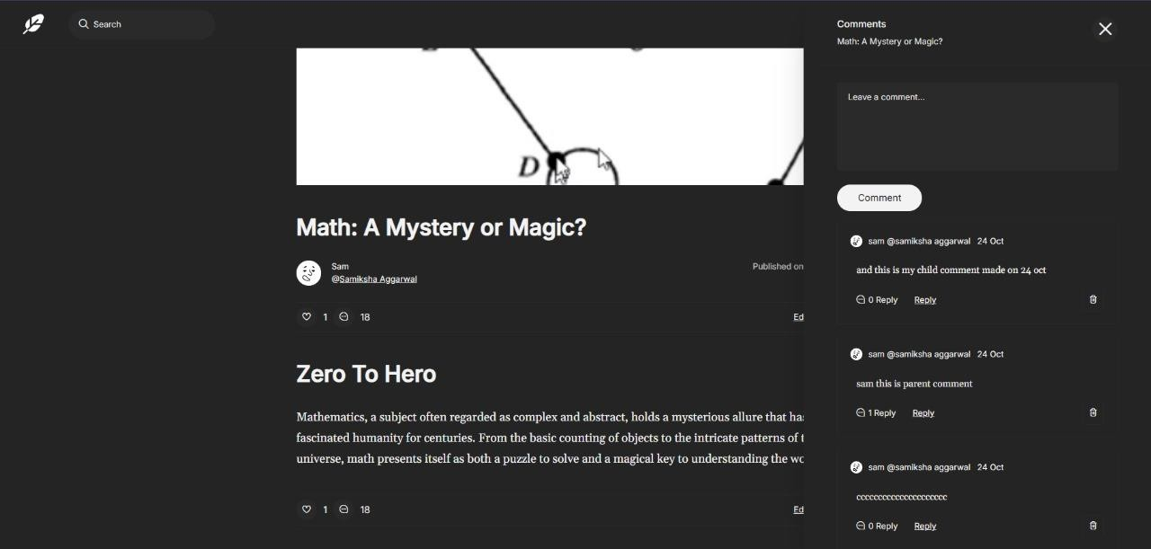

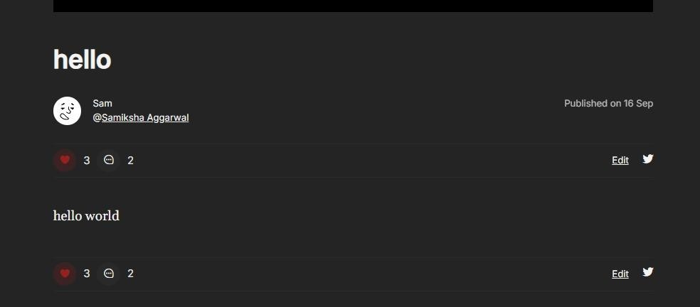

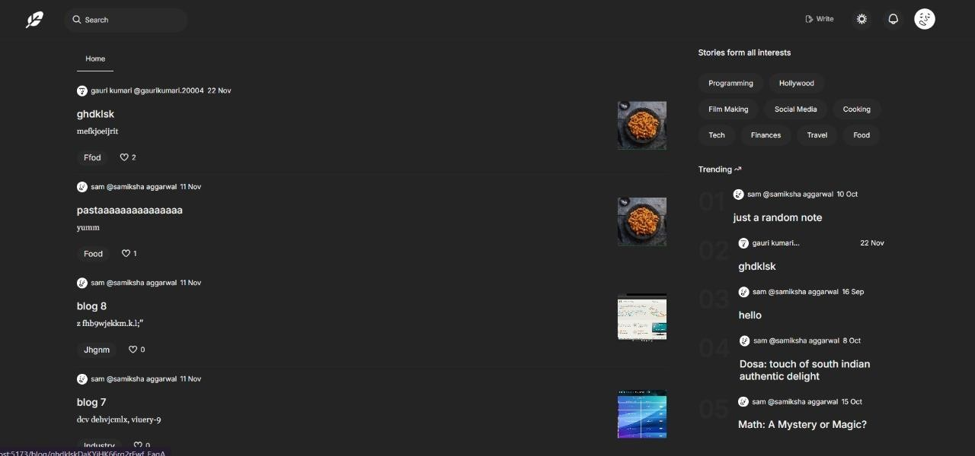

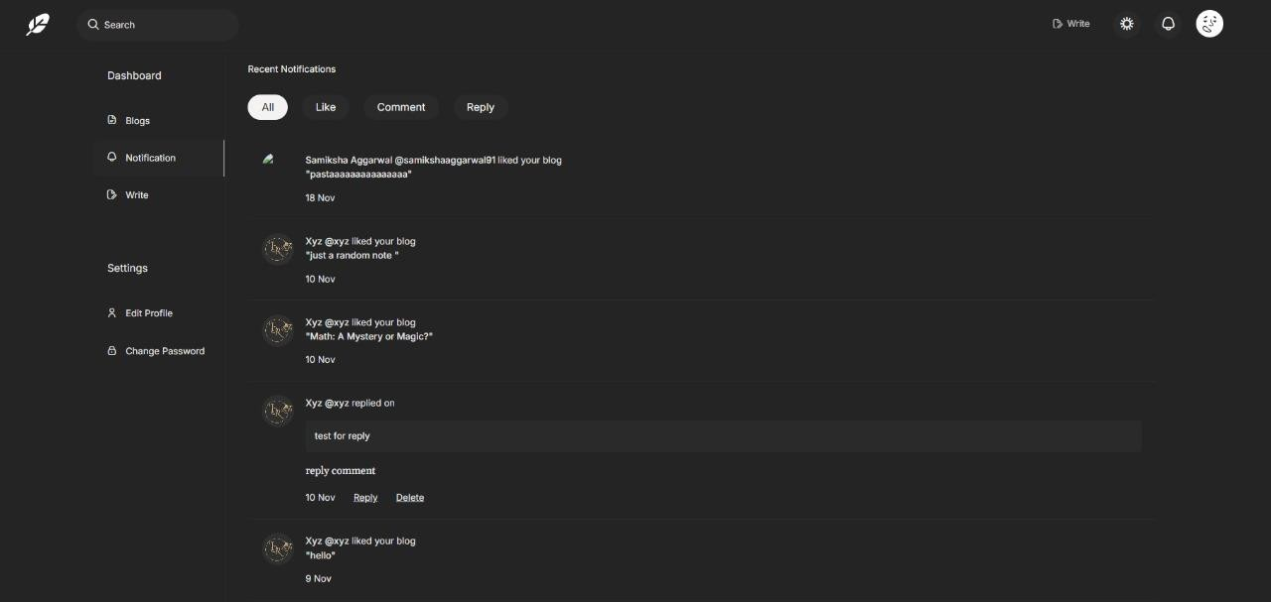

1. **Conclusion**

The vlogging website project aims to provide a robust platform for vloggers to upload, manage, and share their content, while fostering greater engagement with their audiences. By addressing issues like ease of use, video organization, scalability, and monetization, this platform seeks to empower content creators in their digital journey. With user-friendly features and scalability, it is expected to become a go-to destination for vloggers across various domains.

## Future Scope

**Mobile Application**: Developing a mobile app to enhance accessibility for creators and viewers.

**Monetization Options**: Adding features such as ad integration, premium subscriptions, and merchandise sales for content creators.

**AI-powered Video Recommendations**: Implementing machine learning algorithms for personalized content suggestions.

**Live Streamin**g: Enabling creators to host live streams and interact with their audience in real time.

## Bibliography/References:

1. “Run JavaScript everywhere,” Nodejs.org. [Online]. Available: https://nodejs.org/en. [Accessed: 18-Sep-2024].
2. “React,” React.dev. [Online]. Available: https://react.dev/. [Accessed: 18-Sep- 2024].
3. “Express - Node.js web application framework,” Expressjs.com. [Online]. Available: https://expressjs.com/. [Accessed: 18-Sep-2024].
4. “Documentation - Tailwind CSS,” Tailwindcss.com. [Online]. Available: https://v2.tailwindcss.com/docs. [Accessed: 18-Sep-2024].
5. “Github Docs,” github.com Available: https://docs.github.com/en